**LAB – 3**

AIM – Shell Scripting Programs

Shruti Mishra

21BCP110

1. **Write a shell script to print user input.**

**CODE :**

read -p "Enter your name: " input

echo "Your name is $input ! "

**OUTPUT :**

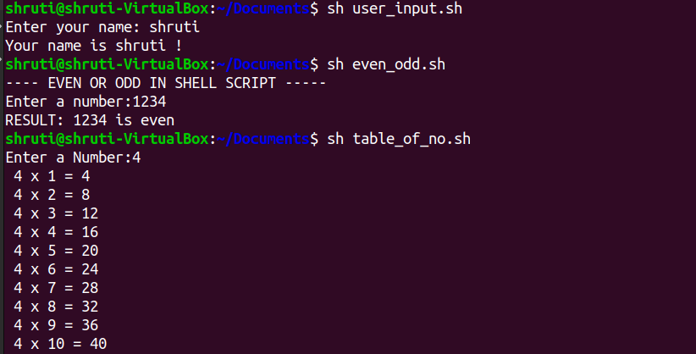

1. **Write a shell script to find whether a number is even or odd.**

**CODE:**

echo "---- EVEN OR ODD IN SHELL SCRIPT -----"

echo -n "Enter a number:"

read n

echo -n "RESULT: "

if [ `expr $n % 2` -eq 0 ]

then

echo "$n is even"

else

echo "$n is Odd"

fi

**OUTPUT:**



1. **Write a shell script to print table of a given number.**

**CODE:**

read -p "Enter a Number:" n

i=1

while [ $i -le 10 ]

do

echo " $n x $i = $(( n * i ))"

i=$(( i + 1 ))

done

**OUTPUT:**



1. **Write a shell script to check whether a given number is prime or not.**

**CODE:**

read -p "Enter number:" num

for((i=2; i<=num/2; i++))

do

if [ $((num%i)) -eq 0 ]

then

echo "$num is not a prime number."

exit

fi

done

echo "$num is a prime number."

**OUTPUT:**

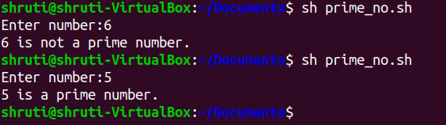

1. **CODE:**

read -p "Enter Amount:" p

read -p "Enter Time:" t

read -p "Enter Rate of Interest:" r

i=` expr $p \* $t \* $r `

i=` expr $i / 100 `

echo "Simple Interest is: $i"

**OUTPUT:**

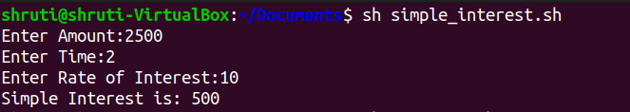

1. **Write a shell script to find sum of n numbers.**

**CODE:**

read -p "Enter Size(n):" n

sum=0

echo "Enter Numbers"

for((i=1 ; i<=n ; i++))

do

read num

sum=$((sum+num))

done

echo "Sum of numbers is:"$sum

**OUTPUT:**

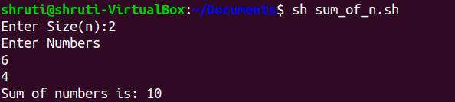

1. **Write a shell script to find largest number among 3 numbers.**

**CODE:**

read -p "Enter Num1:" num1

read -p "Enter Num2:" num2

read -p "Enter Num3:" num3

if [ $num1 -gt $num2 ] && [ $num1 -gt $num3 ]

then

echo "The largest number is" $num1

elif [ $num2 -gt $num1 ] && [ $num2 -gt $num3 ]

then

echo "The largest number is" $num2

else

echo "The largest number is" $num3

fi

**OUTPUT:**

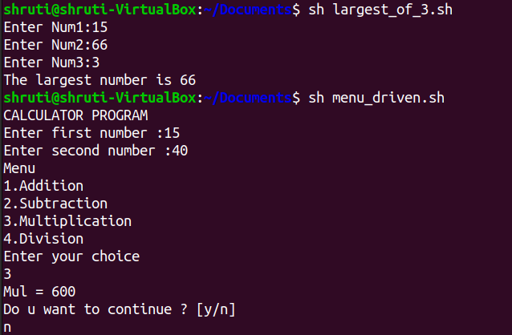

1. **Write a shell script for a menu driven format.**

**CODE:**

sum=0

i="y"

echo "CALCULATOR PROGRAM"

read -p "Enter first number :" n1

read -p "Enter second number :" n2

while [ $i = "y" ]

do

echo "Menu"

echo "1.Addition"

echo "2.Subtraction"

echo "3.Multiplication"

echo "4.Division"

echo "Enter your choice"

read ch

case $ch in

1)sum=`expr $n1 + $n2`

echo "Sum ="$sum;;

2)sub=`expr $n1 - $n2`

echo "Sub = "$sub;;

3)mul=`expr $n1 \* $n2`

echo "Mul = "$mul;;

4)div=`echo $n1 / $n2 | bc -l`

echo "Div = "$div;;

*)echo "Invalid choice";;

esac

echo "Do u want to continue ? [y/n]"

read i

if [ $i != "y" ]

then

exit

fi

done

**OUTPUT:**



1. **Write a shell script to display Fibonacci series up to n terms.**

**CODE:**

echo "How many number of terms to be generated in Fibonacci series ?"

read n

function fib

{x=0

y=1

i=2

echo "Fibonacci Series up to $n terms :"

echo "$x"

echo "$y"

while [ $i -lt $n ]

do

i=`expr $i + 1 `

z=`expr $x + $y `

echo "$z"

x=$y

y=$z

done}

r=`fib $n`

echo "$r"

**OUTPUT:**

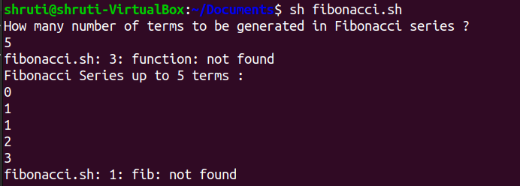

1. **Write a shell script to check if the current year is a leap year or not.**

**CODE:**

read -p "Enter the Year:" y

year=$y

y=$(( $y % 4 ))

if [ $y -eq 0 ]

then

echo "$year is Leap Year!"

else

echo "$year is not a Leap Year!"

fi

**OUTPUT:**

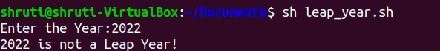

1. **Write a shell script to print half pyramid using numbers.**

**CODE:**

num=1

rows=5

for((i=1; i<=rows; i++))

do

for((j=1; j<=i; j++))

do

echo -n "$num "

num=$((num + 1))

done

num=1

echo

done

**OUTPUT:**

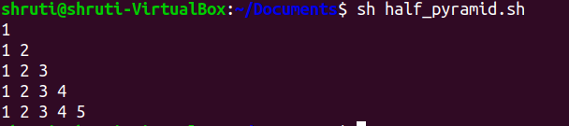

1. **Write a shell script to convert lowercase to uppercase.**

**CODE:**

read -p "Enter the string:" s

upperstr=$(echo $s | tr '[:lower:]' '[:upper:]')

echo "Inputed Lowercase String : $s"

echo "Uppercase String : $upperstr"

**OUTPUT:**

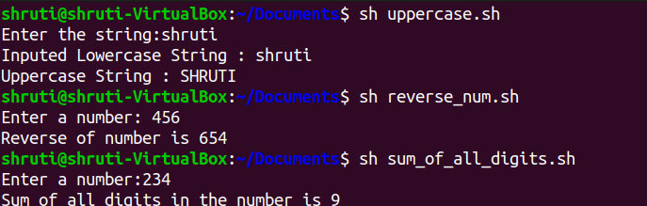

1. **Write a shell script to find reverse of a given number.**

**CODE:**

read -p "Enter a number: " number

temp=$number

while [ $temp -ne 0 ]

do

reverse=$reverse$((temp%10))

temp=$((temp/10))

done

echo "Reverse of number is $reverse"

**OUTPUT:**



1. **Write a shell script to print sum of all digit of a number.**

**CODE:**

read -p "Enter a number:" num

sum=0

while [ $num -gt 0 ]

do

mod=`expr $num % 10`

sum=`expr $sum + $mod`

num=`expr $num / 10`

done

echo "Sum of all digits in the number is "$sum

**OUTPUT:**



1. **Write a shell script to find factorial of a given number.**

**CODE:**

read -p "Enter a number:" num

fact=1

for((i=2;i<=num;i++))

{

fact=$((fact * i)) #fact = fact * i

}

echo "The factorial of $num is $fact"

**OUTPUT:**



1. **Write a shell script which print “INVALID NUMBER OF ARGUMENTS ” if more than 4 command line arguments othervise print “VALID NUMBER OF ARGUMNETS”.**

**CODE:**

echo $1 $2 $3 $4

if [ $# -eq 4 ]

then

echo "Valid arguments"

else

echo "Invalid arguments"

fi

**OUTPUT:**

